A-101 Eval
Full image:
Overlay:
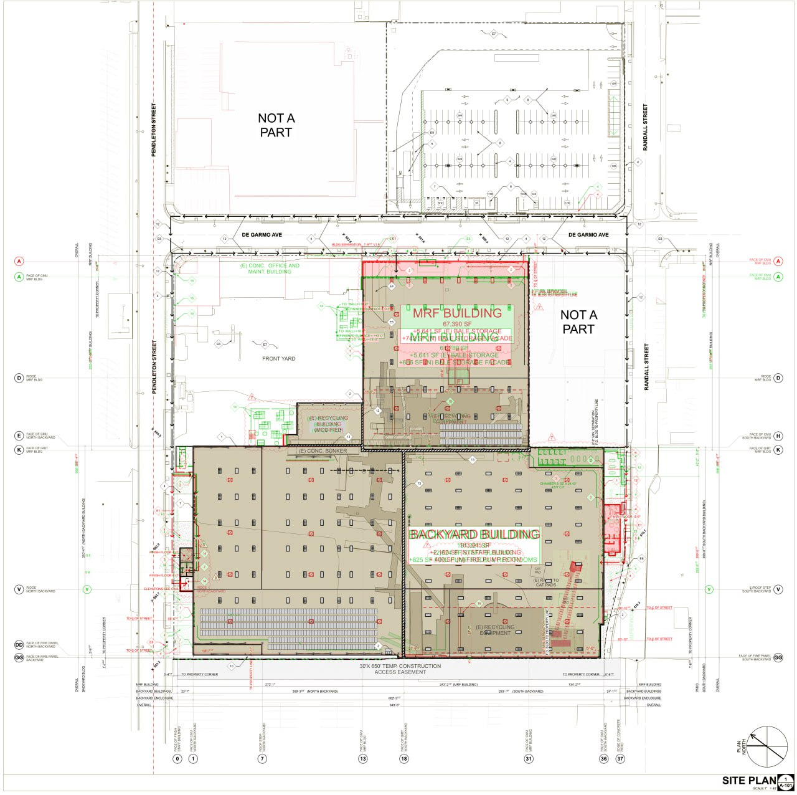
Before:
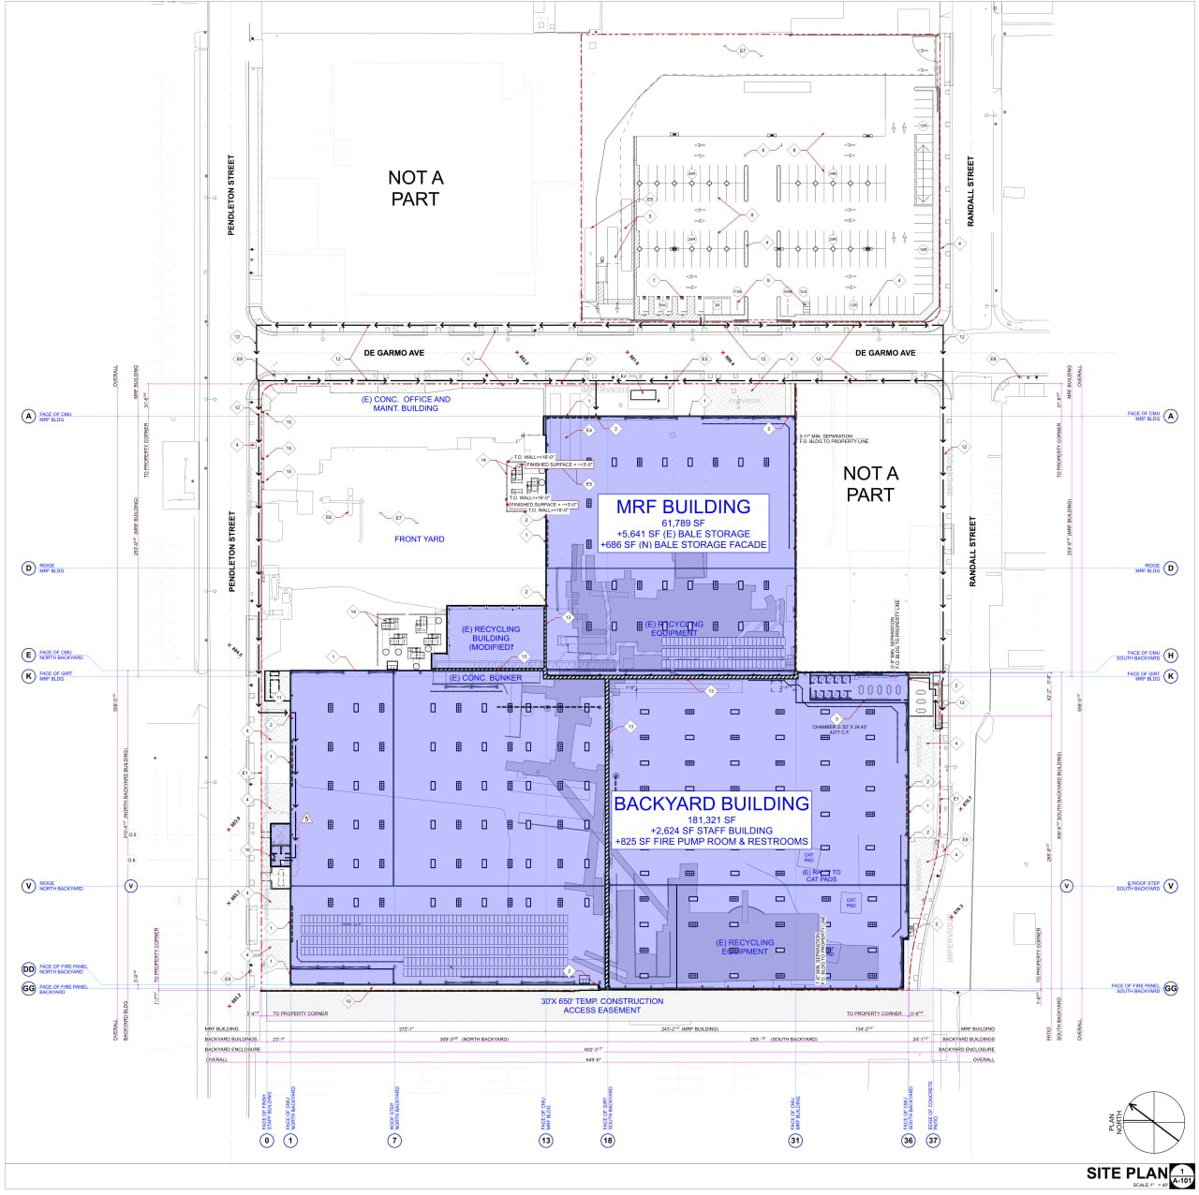
After:
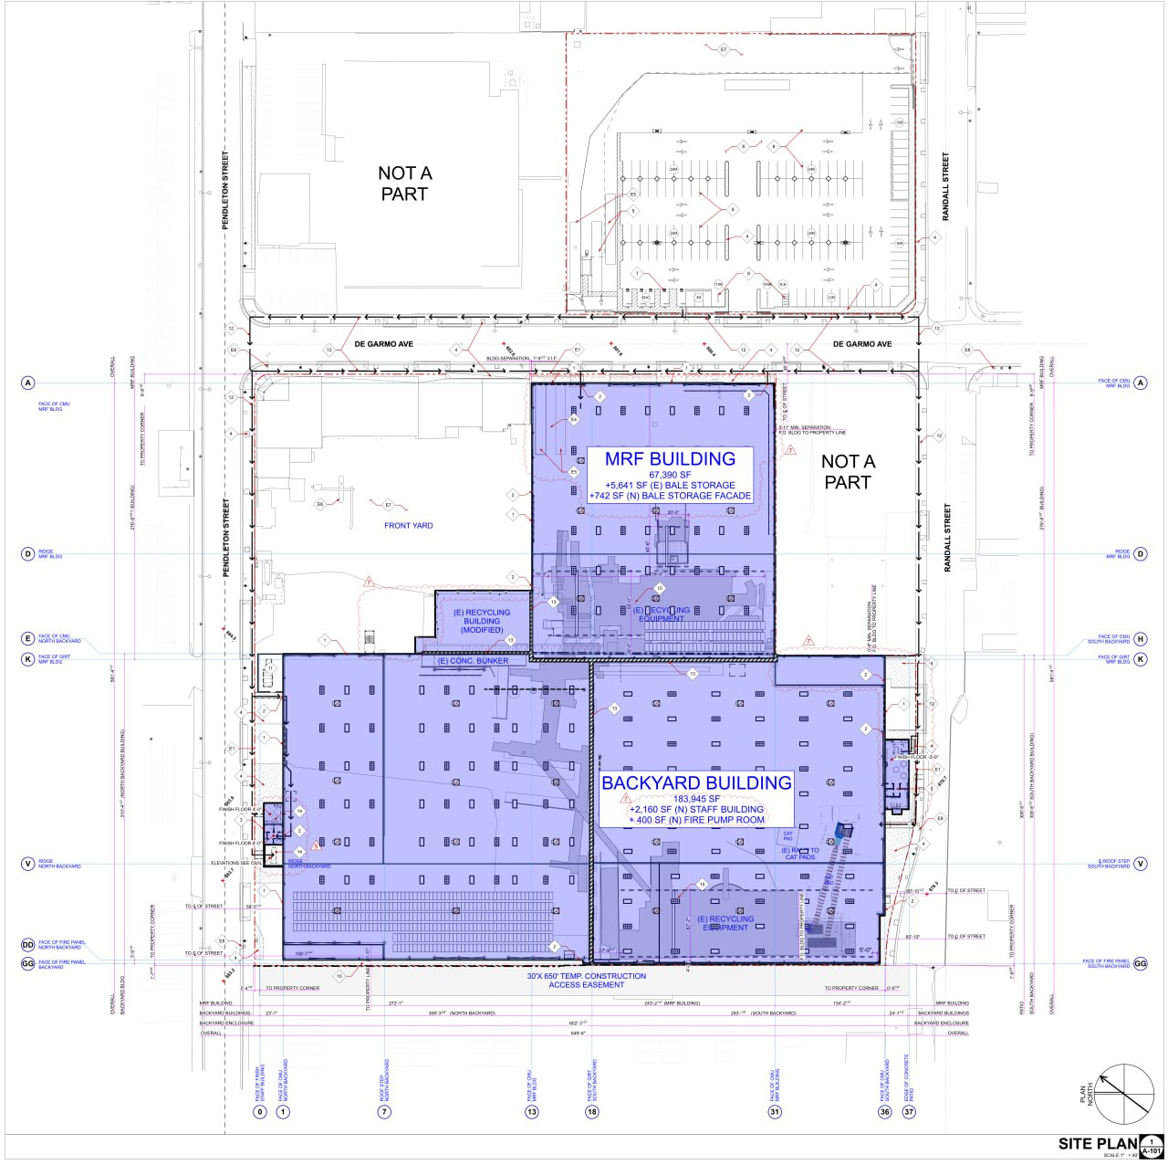
Crop 1:
Overlay Before After
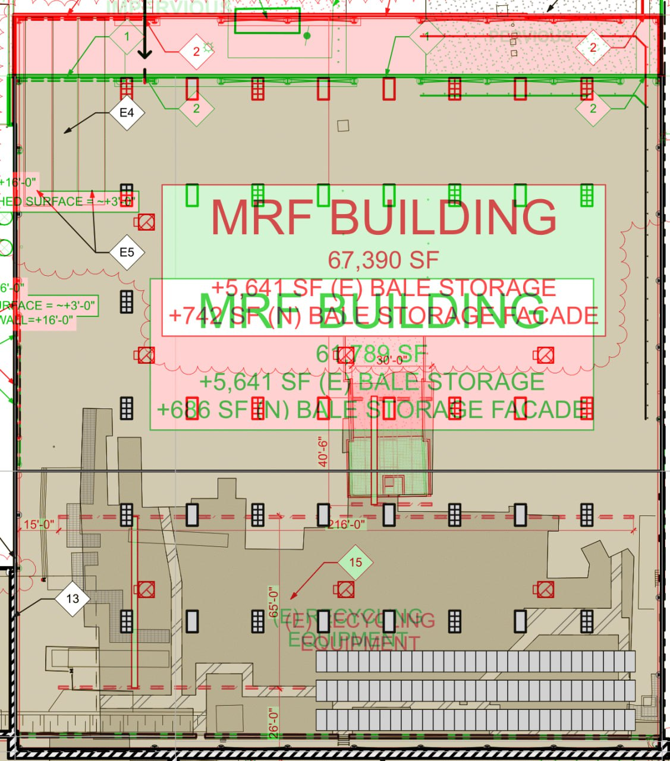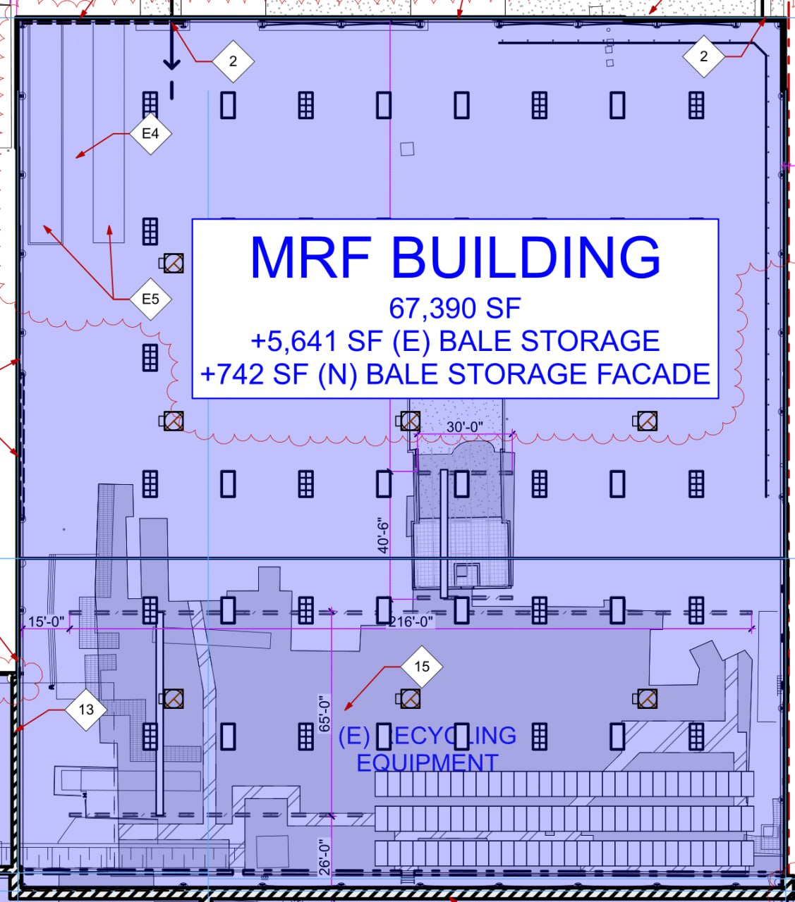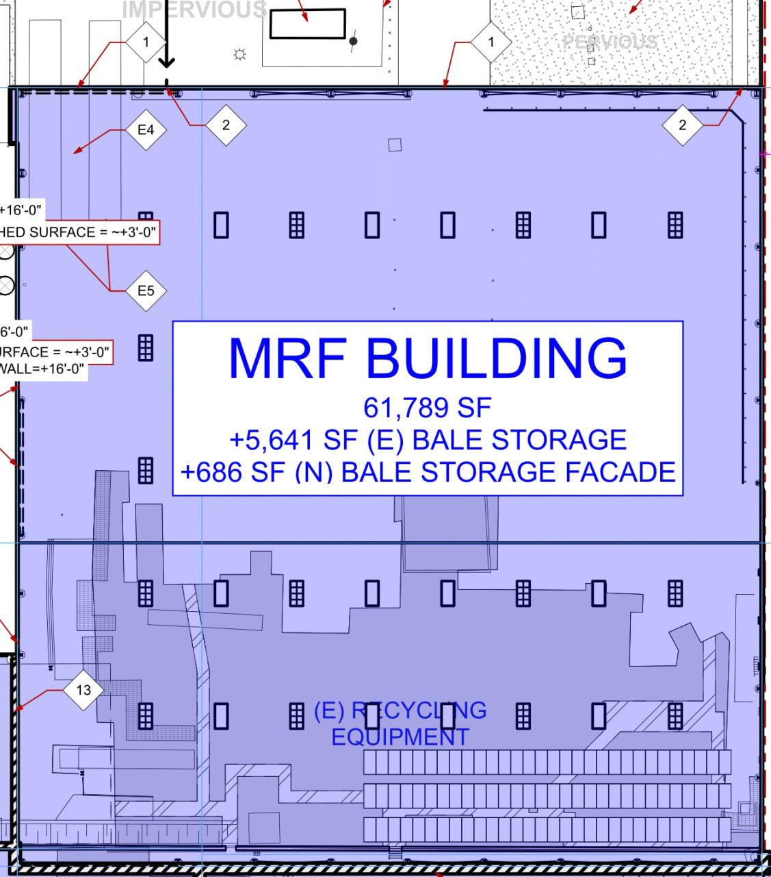
Action: Decrease, Aspect: Door, Mark: 101A

Crop 2:
Overlay: Before After
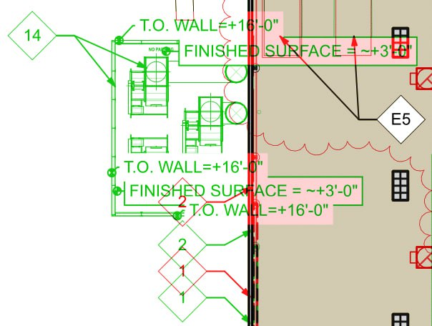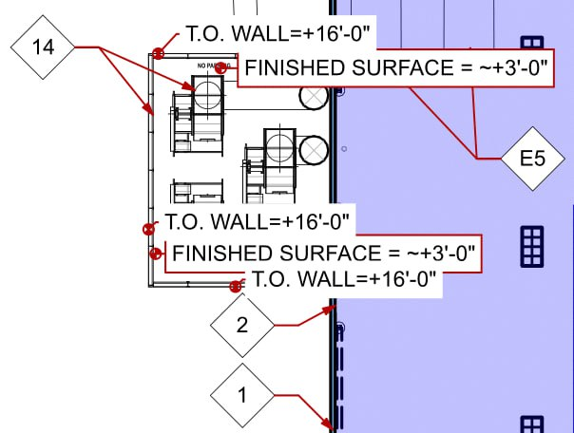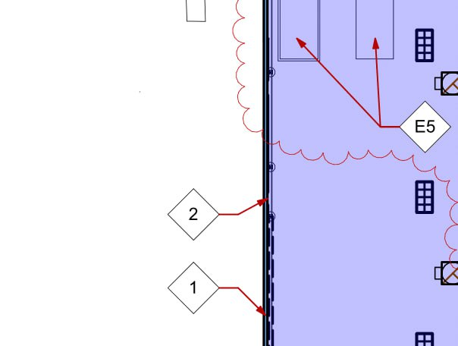

Action: Remove, Aspect: Ventilation equipment and screening, RelativeLocation: To the left of MRF Building

Crop 3:
Overlay:
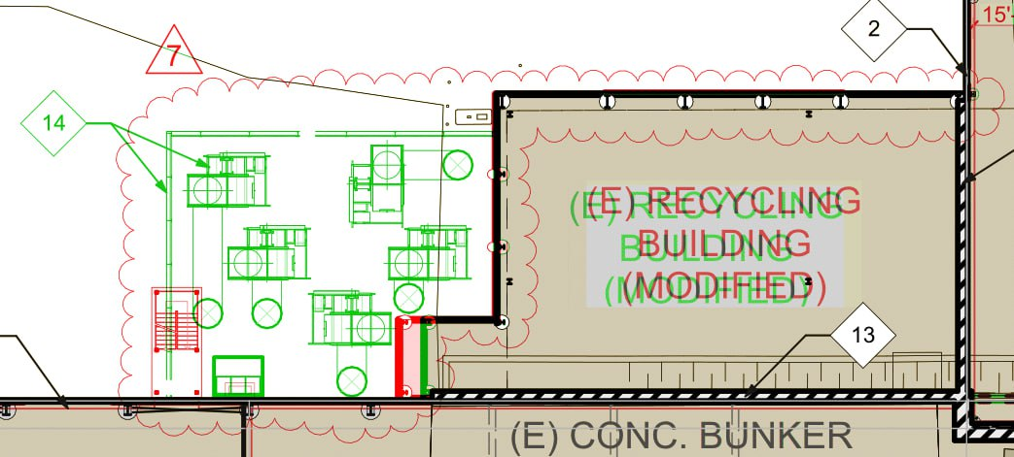
Before:
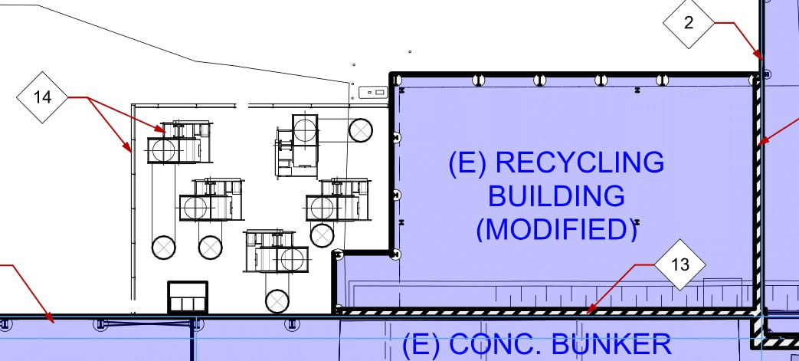
After:
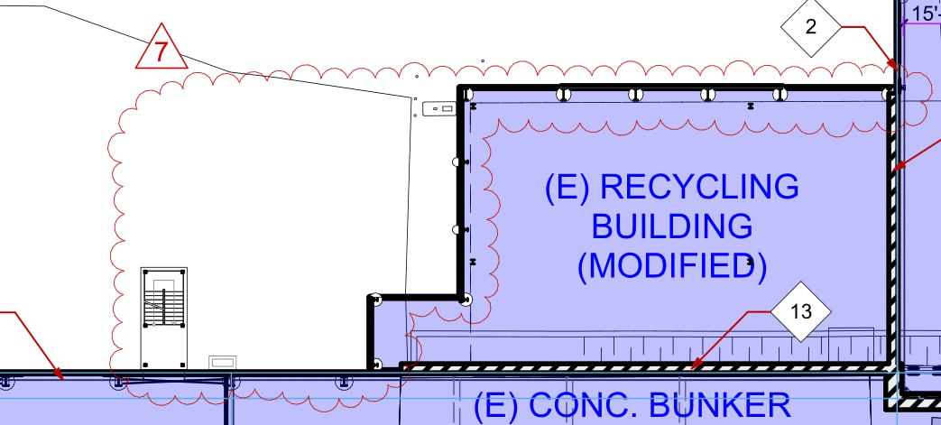

Action: Extend. Aspect: (E) RECYCLING BUILDING (MODIFIED)
Action:Remove. Aspect: Mechanical equipment (suspect not noted)
Action: Add. Aspect: staircase

Crop 4:
Overlay: Before After
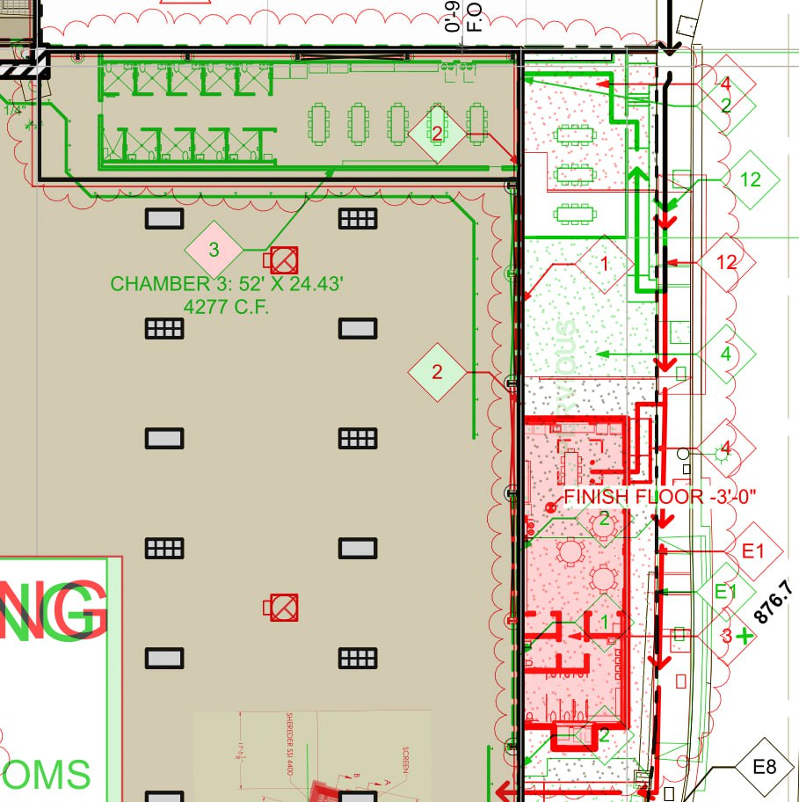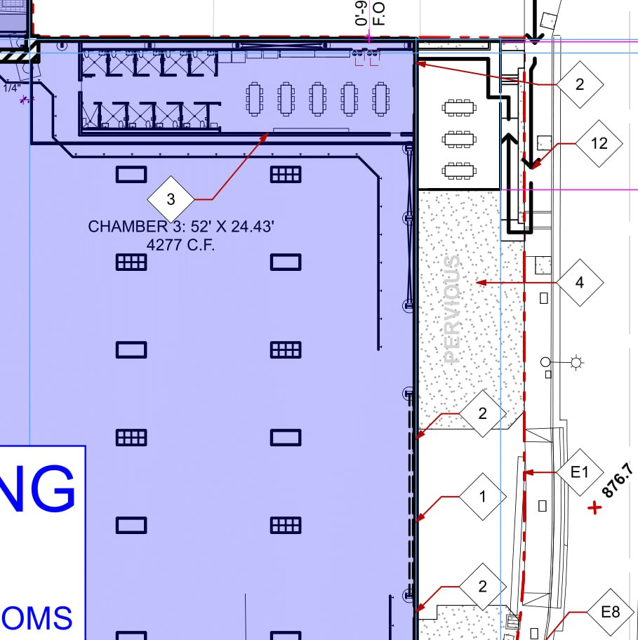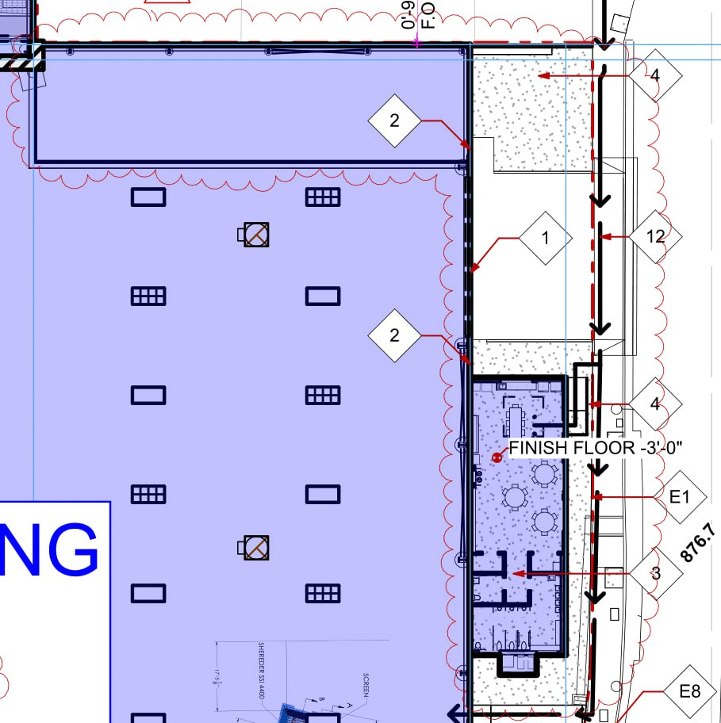
Action:Add Aspect: outdoor balcony. Location: Backyard Building

Crop 5:
Overlay: Before: After:
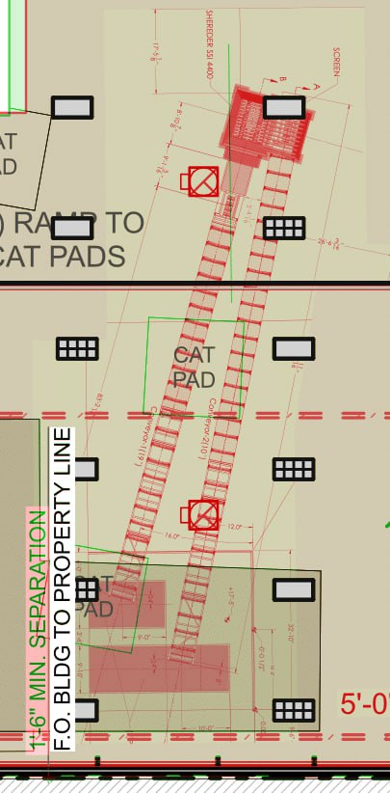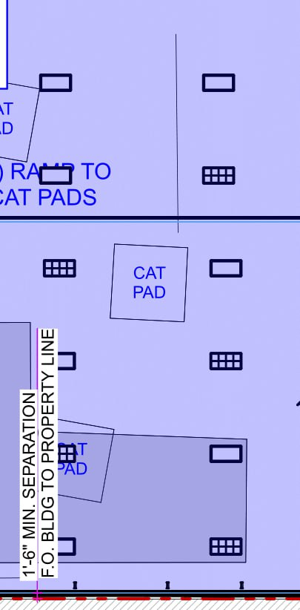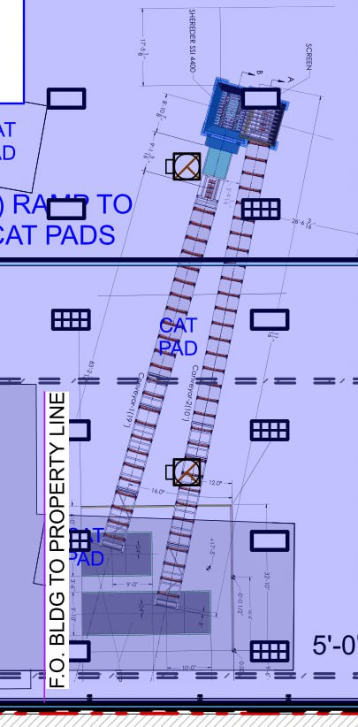
Action: Add. Aspect: Crane. Location: Backyard Building

Crop 6:
Overlay: Before: After:
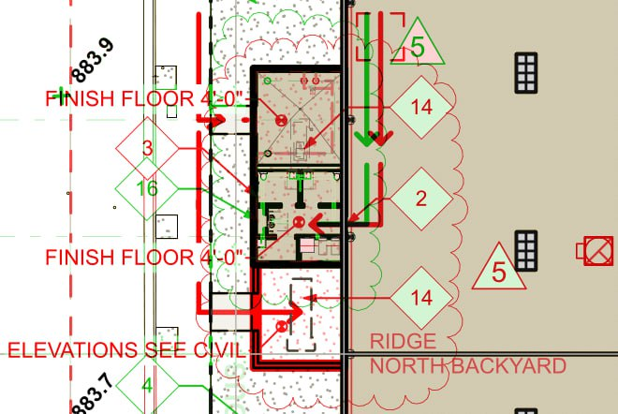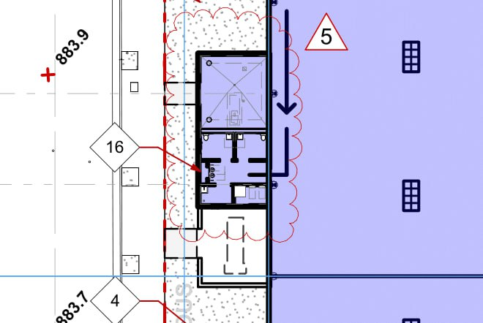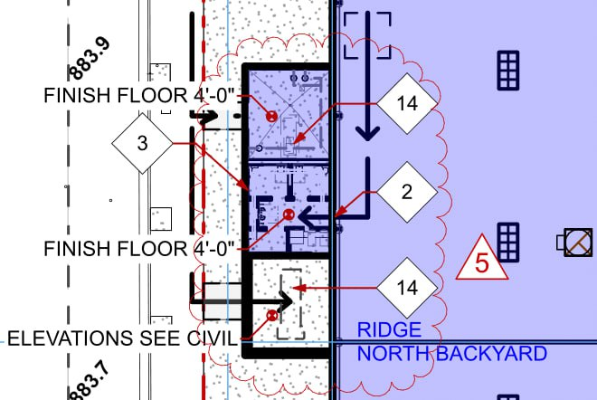

Action: Change. Aspect: ventilation equipment and screening to Genset & firepump room
Action: Add. Aspect: Man door entrace/Exit. Location: Genset & firepump room
Action: Add. Aspect: Finish Floor 4’-0”. Location:Genset & firepump room

Crop 7:
Overlay: Before: After:
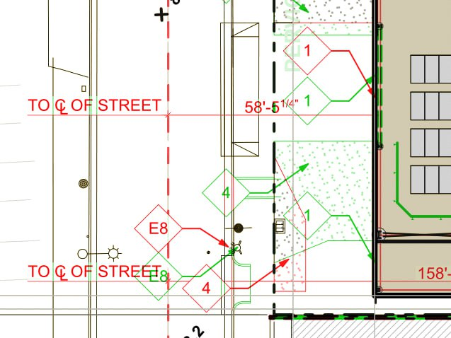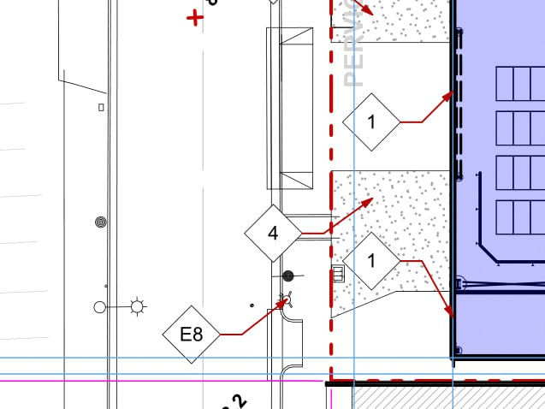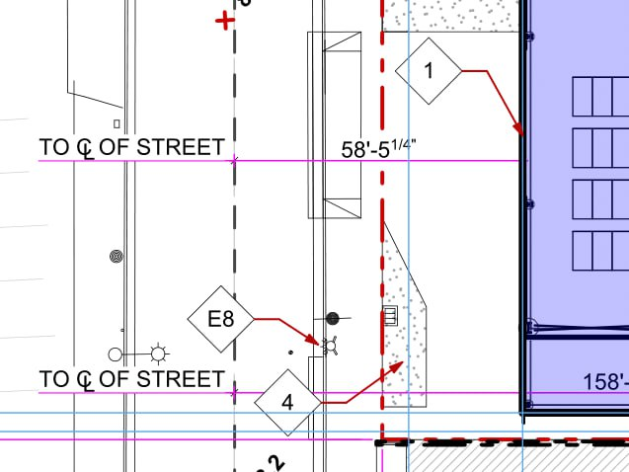

Action: Reduce. Aspect: landscape area. Location: left corner of the building.

Crop 8:
Overlay:
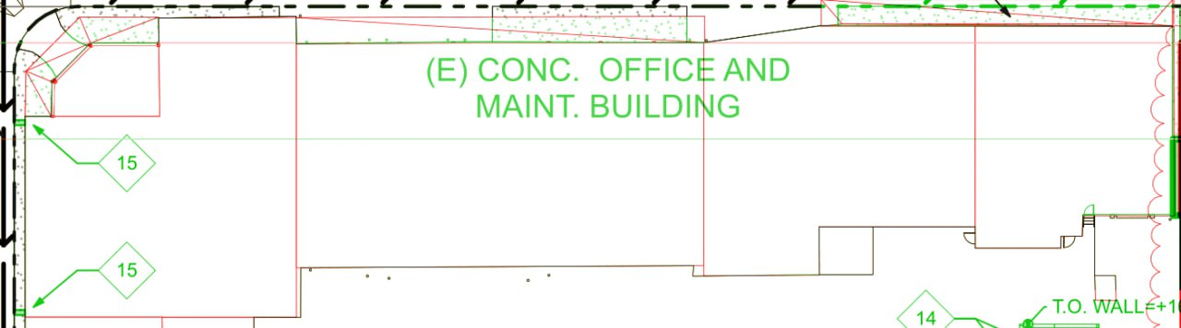
Before:
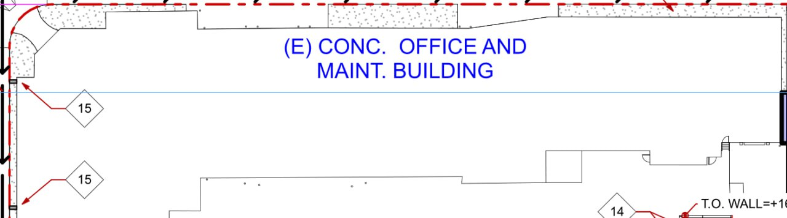
After:

Action: Remove
Aspect: (E) CONC. OFFICE AND MAINT. BUILDING

Crop 9:
Overlay:
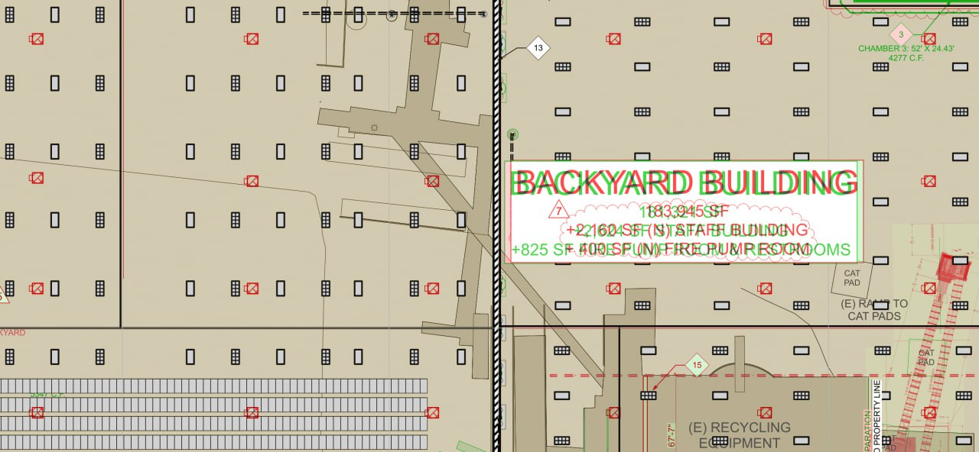
Before:
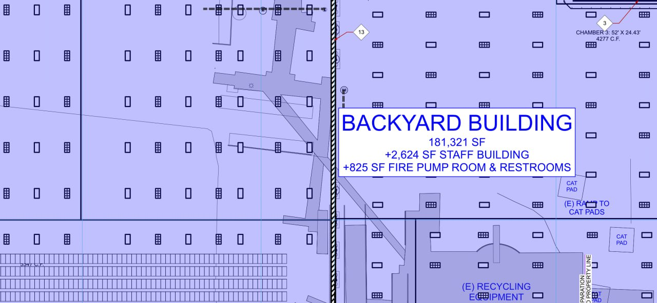
After:
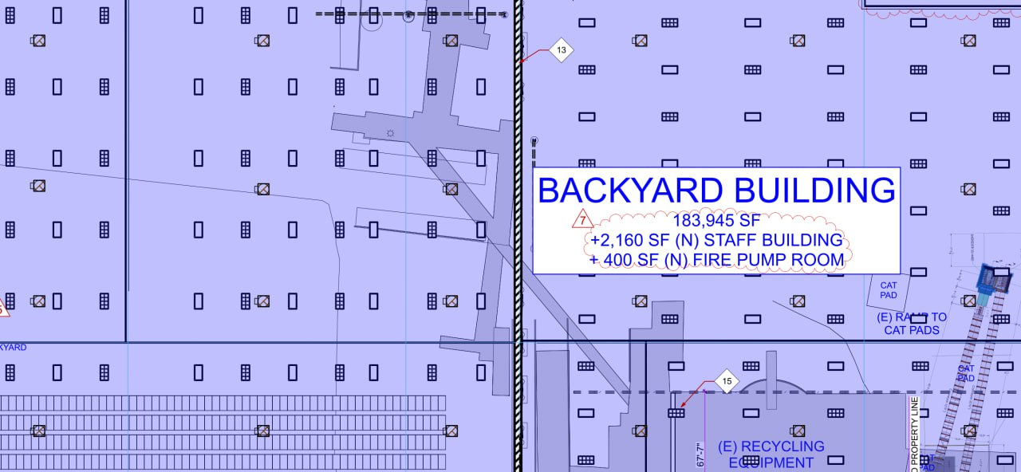

Action: Add
Aspect:Structural Pillar (suspecting, no show or keynote on the drawing)
Value: 24
Location: Backyard Building

Action: Change
Aspect: Area
Value: from 181,321 SF to 183,945 SF
Location: Backyard Building

Action: Change
Aspect: Area
Value: from 2624 SF to 2160 SF
Location: Staff Building

Action: Change
Aspect: Area
Value: from 825 SF to 400 SF
Location: Fire Pump Room

Crop 10:
Overlay: Before: After:
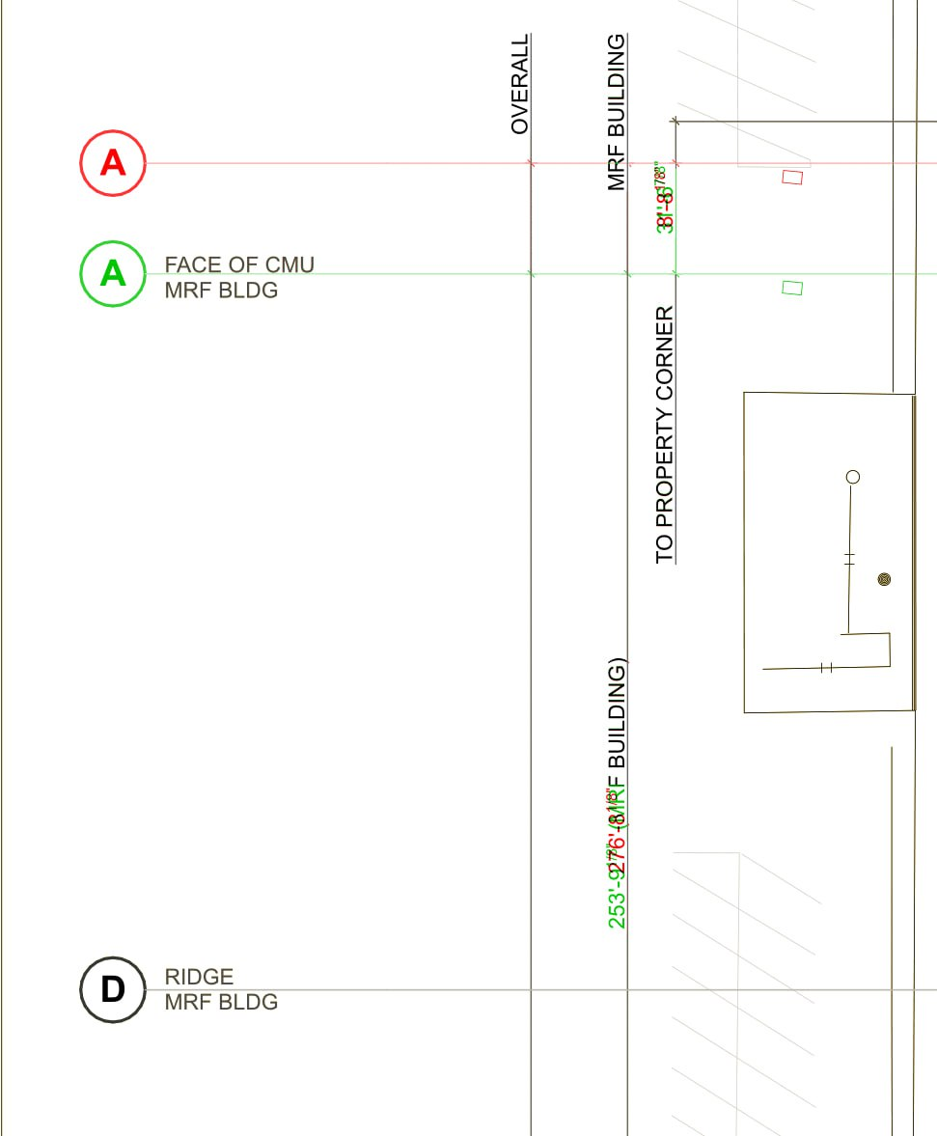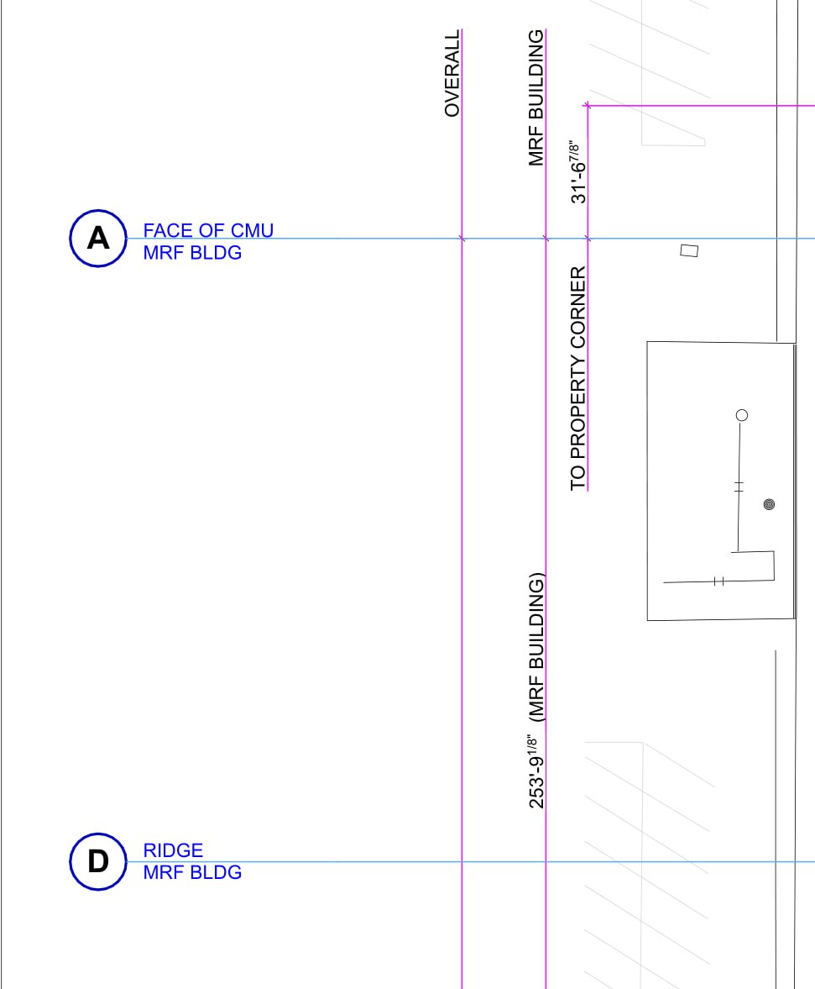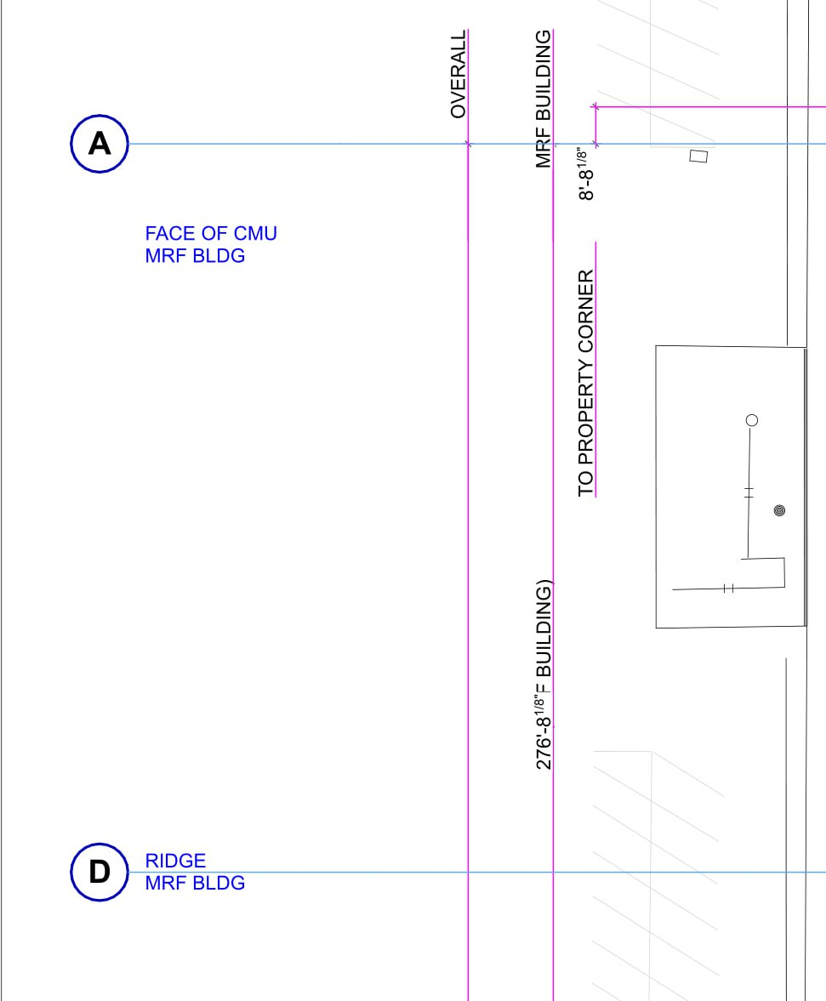

Action:Move
Aspect:GridlineA
Direction:Up
Value:(253’-9 1/16”) to ( 276’-8 1/18”)
Location:From GridlineD

